Walk In Clinic

SEG 2105 A – Intro to Software Engineering

Fall 2019

School of Engineering University of Ottawa

Course Coordinator:  Professor Forward

Group Member’s:

Soorya Saravanapavan

Hrithik Shah

Dylan Boyling

Sultan Oloyede

Submission Date:

For our culminating project, we were given the task of creating an android application that allows users to interact with several walk-in clinics for the purpose of book appointments.

This required the creation of different user types with varying administrative capabilities and features that would ultimately make it easier for users and clinics to navigate the app. Our app (Clinic On Call) uses external service such as Firebase, CircleCi, and the Google API. Firebase is used to handle user authentication. CircleCi was used to manage different builds of our application. The Google API was used to implement map features into the application. *Feel free to edit*

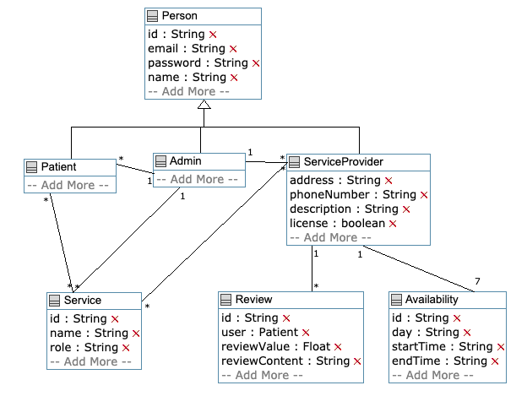

|  |  |  |  |  |
| --- | --- | --- | --- | --- |
|  | Deliverable 1 | Deliverable 2 | Deliverable 3 | Deliverable 4 |
| Hrithik  Shah |  |  |  |  |
| Soorya  Saravanapavan |  |  |  |  |
| Sultan  Oloyede | - Created a splash page | - Implemented a google API map | - UI Design | - UI Design |
| Dylan  Boyling |  |  |  |  |

In the process of constructing our application many lessons were learned in regard to app development. One major take away was the importance of communication. Sharing ideas and having an understand of each individual members progression was crucial to maintaining group chemistry. Another major lesson learned was running tests to find errors. In the process of developing our application, code for different parts of the app were merged together. In doing so many statements clashed with each and as a result time had to be dedicated to making pieces of code work together. *Feel free to add or edit *

